TECHNOLOGY STACK (ARCHITECTURE AND STACK)

|  |  |
| --- | --- |
| DATE | 24 OCT 2022 |
| TEAM ID | PNT2022TMID35612 |
| PROJECT NAME | Early Detection of Chronic Kidney Disease Using Machine Learning |
| TOTAL MARKS | 4 |

**TECHNICAL ARCHITECTURE**

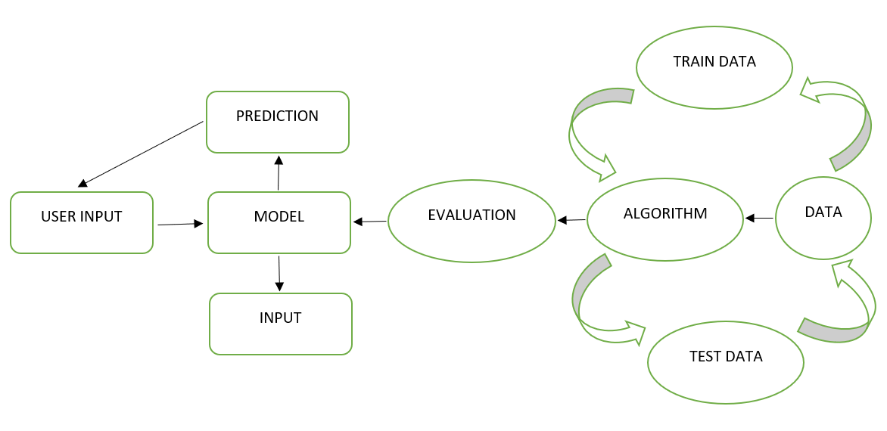

|  |  |  |
| --- | --- | --- |
| SNO | COMPONENTS DESCRIPTION | TECHNOLOGY |
| 1 | User Interface – User can interact with our application through web User Interface. | HTML, CSS and Python flask. |
| 2 | Application Logic - Test Vitals Form will be shown once logged in , when the user clicks on the test vital form button he/she will be directed to the form page to enter the vitals for prediction. | Front end- HTML ,CSS MySQL, Python flask Back end - Python |
| 3 | Database Data type - String and Numeric. | MySQL. |
| 4 | Machine Learning Model gets the data from the user and  predicts the data with tested and trained dataset models. | Data Recognition Model etc. |
| 5 | Cloud Database Service on Cloud | IBM. |
|  |  |  |

**Description Technology**

1. Open-Source Frameworks Python Script, Java script , python , HTML, CSS & MySQL.
2. Security Implementations -Makes sure that data that is transferred is secured.
3. Scalable Architecture -Provided with more prediction and one reliable solution.
4. Availability -Real time application.
5. Performance- We will be able to send huge amount of data and wireless connectivity.

**Application characteristics**

|  |  |  |  |
| --- | --- | --- | --- |
| **S.NO** | **CHARACTERISTICS** | **DESCRIPTION** | **TECHNOLOGY** |
| **1** | Open sources framework | Frameworks used | Jupyter |
| **2** | Security Implementations | List all the security / access controls implemented, use of firewalls etc. | SHA-256, Encryptions, IAM Controls, OWASP etc. |
| **3** | Scalable Architecture | Scalability of architecture | 3-tier architecture |
| **4** | Availability | Availability of application | Use of cloud services which use load balances |
| **5** | Performance | Design consideration for the performance of the application | Number of requests per second is 5. Cache is used for fast access |